**Question 1**

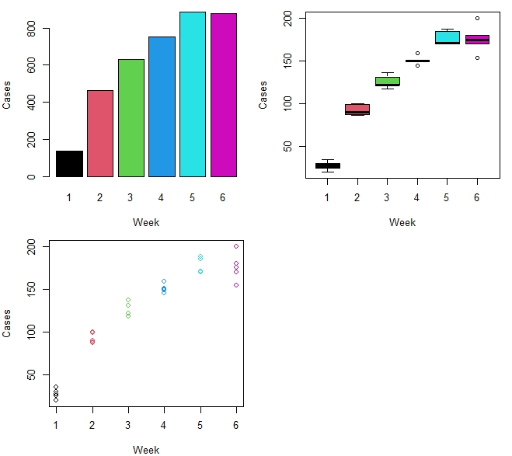

Figure : Various plot between week and cases

The bar plot shows the representation of the above table and it can be seen that week 5 had the most cases recorded in the 5 cities combined and week 1 had the least number of cases recorded. The boxplot shows the statistical estimates of the data and it can be seen that some cities had some outlying cases different from the mean for week 4 and 6. And lastly, the scatter plot shows that the number of cases increases as the weeks increases which is a positive relation. Also, it can be noticed that a linear model could be a possible fit for this data, but would not fit the data properly therefore, a curvilinear model might be best suitable for this data.

Using the first Order

Coefficients:

Estimate Std. Error t value Pr(>|t|)

(Intercept) 23.053 8.018 2.875 0.00763 **

week 29.109 2.059 14.139 2.83e-14 ***

---

Signif. codes: 0 ‘***’ 0.001 ‘**’ 0.01 ‘*’ 0.05 ‘.’ 0.1 ‘ ’ 1

Residual standard error: 19.26 on 28 degrees of freedom

Multiple R-squared: 0.8771, Adjusted R-squared: 0.8728

F-statistic: 199.9 on 1 and 28 DF, p-value: 2.835e-14

*Output 1: Regression Summary of 1st order polynomial*

**Analysis of Variance Table**

Response: cases

Df Sum Sq Mean Sq F value Pr(>F)

Week 1 74140 74140 199.91 2.835e-14 ***

Residuals 28 10384 371

---

Signif. codes: 0 ‘***’ 0.001 ‘**’ 0.01 ‘*’ 0.05 ‘.’ 0.1 ‘ ’ 1

*Output 2: ANOVA Summary of 1st order polynomial*

The first order shows that the predictor is still significant with R-squared and adjusted R-squared values of 0.8771 and 0.8728 respectively, and the ANOVA output also indicated that the model is significant.

Using second order

Coefficients:

Estimate Std. Error t value Pr(>|t|)

(Intercept) -37.0800 7.9042 -4.691 6.98e-05 ***

week 74.2086 5.1711 14.351 3.74e-14 ***

I(week^2) -6.4429 0.7232 -8.909 1.59e-09 ***

---

Signif. codes: 0 ‘***’ 0.001 ‘**’ 0.01 ‘*’ 0.05 ‘.’ 0.1 ‘ ’ 1

Residual standard error: 9.88 on 27 degrees of freedom

Multiple R-squared: 0.9688, Adjusted R-squared: 0.9665

F-statistic: 419.4 on 2 and 27 DF, p-value: < 2.2e-16

*Output 3: Regression Summary of 2nd order polynomial*

**Analysis of Variance Table**

Response: cases

Df Sum Sq Mean Sq F value Pr(>F)

week 1 74140 74140 759.475 < 2.2e-16 ***

I(week^2) 1 7749 7749 79.376 1.592e-09 ***

Residuals 27 2636 98

---

Signif. codes: 0 ‘***’ 0.001 ‘**’ 0.01 ‘*’ 0.05 ‘.’ 0.1 ‘ ’ 1

*Output 4: ANOVA Summary of 2nd order polynomial*

The second order polynomial shows that the addition of the higher power predictor improves the model and increases the R-squared and adjusted R-squared value to 0.9688 and 9.9665. Also, the ANOVA table indicates that the overall model is still significant with the addition of the new term.

Using third order

Coefficients:

Estimate Std. Error t value Pr(>|t|)

(Intercept) -49.8667 15.9759 -3.121 0.00437 **

week 90.2934 18.2031 4.960 3.73e-05 ***

I(week^2) -11.7706 5.8249 -2.021 0.05372

I(week^3) 0.5074 0.5504 0.922 0.36509

---

Signif. codes: 0 ‘***’ 0.001 ‘**’ 0.01 ‘*’ 0.05 ‘.’ 0.1 ‘ ’ 1

Residual standard error: 9.908 on 26 degrees of freedom

Multiple R-squared: 0.9698, Adjusted R-squared: 0.9663

F-statistic: 278.3 on 3 and 26 DF, p-value: < 2.2e-16

*Output 5: Regression Summary of 3rd order polynomial*

**Analysis of Variance Table**

Response: cases

Df Sum Sq Mean Sq F value Pr(>F)

week 1 74140 74140 755.2489 < 2.2e-16 ***

I(week^2) 1 7749 7749 78.9340 2.344e-09 ***

I(week^3) 1 83 83 0.8498 0.3651

Residuals 26 2552 98

---

Signif. codes: 0 ‘***’ 0.001 ‘**’ 0.01 ‘*’ 0.05 ‘.’ 0.1 ‘ ’

*Output 6: ANOVA Summary of 3rd order polynomial*

It can be observed from the ANOVA output table of the addition of a third order polynomial will make the term insignificant to the model with a p-value of 0.3651. The summary value also indicated that the third order term makes is insignificant as a predictor and it also reduces the adjusted R-square from 0.9665 to 0.9663.

Therefore, the best order of polynomial to create a suitable model is the second order polynomial as it has all predictors significant with the highest adjusted R-squared value

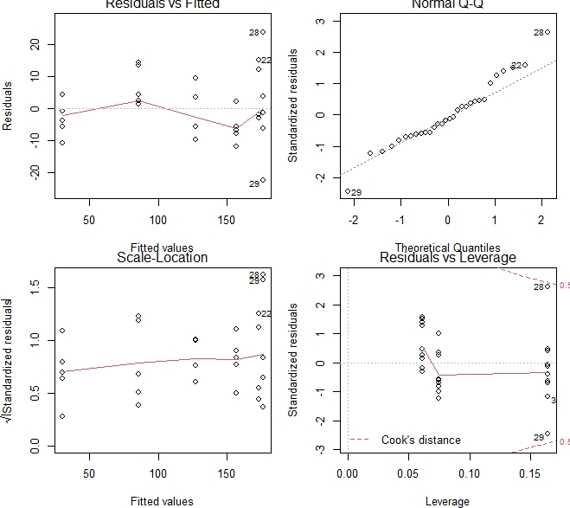

Figure : Assumption Plots

* The model assumptions for the second order polynomial suggests that the residuals are fairly randomly distributed along the line which indicates that the model provides a decent fit to the data. This can be observed in the Residuals vs Fitted plot.
* The Normal Q-Q plot provides a fairly safe assumption that the data is normally distributed as majority of the observed data points are in close proximity to the line.
* The scale location plot satisfies our assumption for homoscedasticity as the red line is roughly horizontal and the spread of residuals around the line is randomly scattered showing patterned distribution. Therefore, there is a roughly equal variability with the fitted values.
* Residuals vs Leverage plot does not show any high influence points but there are some points that should be further investigated as they are potentially influential (28 and 29) and also, these points are potential outliers as well.

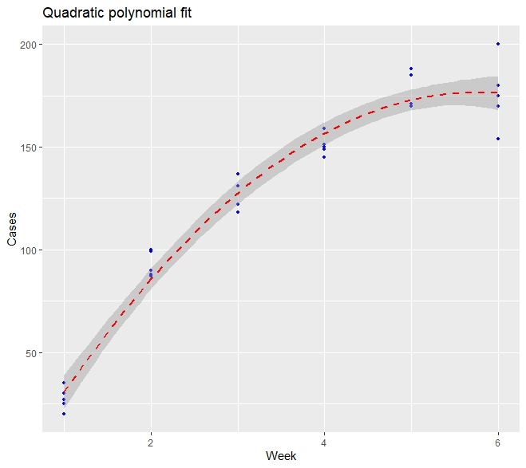

Figure : Quadratic Model for data

It can be seen that after plotting the scattered plot to the data, the second order polynomial is fit nicely with the data, and the 95% confidence band contains most of the data points. Therefore, the regression model can be considered appropriate for the data.

**Question 2**

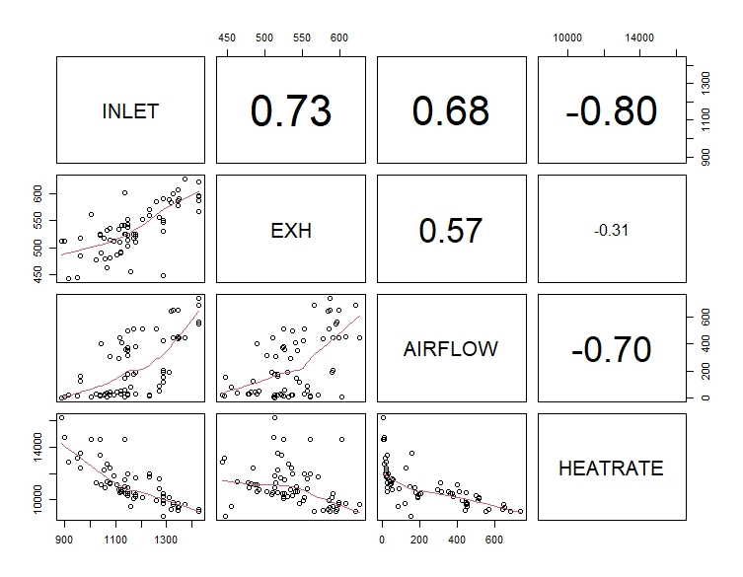

Figure : Pairs plot showing correlation between numeric variables

It will be observed from the plot above that the HEATRATE of the gas turbines has a strong negative correlation with INLET and AIRFLOW with a correlation value of -0.8 and -0.7 respectively. However, it has a weak negative correlation with EXH of -0.31.

Also, it can be seen that INLET has a high positive correlation with both EXH and AIRFLOW with values 0.73 and 0.68 respectively. There is a moderate positive correlation between EXH and AIRFLOW of value 0.57.

As we are trying to determine the best combination of measurements to analyse the gas turbine measurement, a regression model would be the preferred choice for the model; the suggested regression model deduced from the pairs plot is the linear regression model as this helps predict the value of the response variable (HEATRATE) based on the values of the other predictors combine The suggested model would be the linear regression model as this helps explain the weight each predictor has on the response variable therefore explaining the high correlation.

**INLET EXH AIRFLOW HEATRATE**

**INLET** 1.000 0.728 0.681 -0.801

**EXH**  0.728 1.000 0.567 -0.314

**AIRFLOW**  0.681 0.567 1.000 -0.703

**HEATRATE** -0.801 -0.314 -0.703 1.000

*Output 7: Correlation Output between INLET, EXH, AIRFLOW, AND HEATRATE*

Coefficients:

Estimate Std. Error t value Pr(>|t|)

(Intercept) 13170.6662 1049.6177 12.548 < 2e-16 ***

INLET -11.6268 0.8755 -13.280 < 2e-16 ***

EXH 22.7362 2.4228 9.384 1.41e-13 ***

AIRFLOW -2.6555 0.4413 -6.017 9.92e-08 ***

---

Signif. codes: 0 ‘***’ 0.001 ‘**’ 0.01 ‘*’ 0.05 ‘.’ 0.1 ‘ ’ 1

Residual standard error: 589.4 on 63 degrees of freedom

Multiple R-squared: 0.8697, Adjusted R-squared: 0.8634

F-statistic: 140.1 on 3 and 63 DF, p-value: < 2.2e-16

*Output 8: Regression Output of the Main effects Model*

Analysis of Variance Table

Response: HEATRATE

Df Sum Sq Mean Sq F value Pr(>F)

INLET 1 107601712 107601712 309.747 < 2.2e-16 ***

EXH 1 25831694 25831694 74.360 2.917e-12 ***

AIRFLOW 1 12578470 12578470 36.209 9.916e-08 ***

Residuals 63 21885332 347386

---

Signif. codes: 0 ‘***’ 0.001 ‘**’ 0.01 ‘*’ 0.05 ‘.’ 0.1 ‘ ’ 1

*Output 9: ANOVA output of Main effects Model*

INLET EXH AIRFLOW

2.751 2.173 1.902

*Output 10: VIF output of predictors*

* The correlation shows that there is a strong positive correlation between INLET and both (EXH and AIRFLOW) with values (0.728, 0.681) respectively and there is a moderate correlation between EXH and AIRFLOW. From this output, it COULD be deduced that multicollinearity exists between the predictors of turbine’s HEATRATE.
* Comparing the correlation output to the regression output, it can be seen that the response variable (HEATRATE) has a negative correlation with all the predictors on the correlation output, but on the regression output, it is notices that the relationship between HEATRATE and EXH is positive which is contrary to their correlation. This output also indicates the presence of multicollinearity.
* The regression output and the ANOVA output indicate that all predictors are significant to the model and the overall model is significant as indicated by the p-value of the F-statistics. With no contradictions between the F and the T statistics, this indicator does not show that the model has multicollinearity.
* The above table is the variance inflation factor (VIF) output of the model; this does not detect any sign of multicollinearity as none of the values are above 10.

Therefore, after considering all indicators of multicollinearity, I found out that out of the 4 indicators, only two (“VIF output” and “F-test and t-test comparison) do not provide indications that multicollinearity exists in the model.

Start: AIC=989.19

HEATRATE ~ 1

Df Sum of Sq RSS AIC

+ INLET 1 107601712 60295496 922.58

+ AIRFLOW 1 83000387 84896822 945.50

+ EXH 1 16586588 151310620 984.22

<none> 167897208 989.19

Step: AIC=922.58

HEATRATE ~ INLET

Df Sum of Sq RSS AIC

+ EXH 1 25831694 34463802 887.10

+ AIRFLOW 1 7818472 52477024 915.27

<none> 60295496 922.58

Step: AIC=887.1

HEATRATE ~ INLET + EXH

Df Sum of Sq RSS AIC

+ AIRFLOW 1 12578470 21885332 858.67

<none> 34463802 887.10

+ INLET: EXH 1 47855 34415948 889.01

Step: AIC=858.67

HEATRATE ~ INLET + EXH + AIRFLOW

Df Sum of Sq RSS AIC

+ INLET: AIRFLOW 1 6056999 15828333 838.97

<none> 21885332 858.67

+ INLET: EXH 1 522081 21363251 859.06

+ EXH: AIRFLOW 1 448267 21437065 859.29

Step: AIC=838.97

HEATRATE ~ INLET + EXH + AIRFLOW + INLET: AIRFLOW

Df Sum of Sq RSS AIC

+ EXH: AIRFLOW 1 4806495 11021838 816.72

+ INLET: EXH 1 1213545 14614788 835.62

<none> 15828333 838.97

Step: AIC=816.72

HEATRATE ~ INLET + EXH + AIRFLOW + INLET: AIRFLOW + EXH: AIRFLOW

Df Sum of Sq RSS AIC

<none> 11021838 816.72

+ INLET: EXH 1 20129 11001709 818.59

*Output 11: Forward Stepwise output including interaction*

Coefficients:

Estimate Std. Error t value Pr(>|t|)

(Intercept) 1.394e+04 1.044e+03 13.353 < 2e-16 ***

INLET -1.514e+01 7.775e-01 -19.470 < 2e-16 ***

EXH 2.884e+01 2.304e+00 12.519 < 2e-16 ***

AIRFLOW -6.895e-01 3.628e+00 -0.190 0.85

INLET: AIRFLOW 2.277e-02 2.999e-03 7.592 2.22e-10 ***

EXH: AIRFLOW -5.430e-02 1.053e-02 -5.158 2.87e-06 ***

---

Signif. codes: 0 ‘***’ 0.001 ‘**’ 0.01 ‘*’ 0.05 ‘.’ 0.1 ‘ ’ 1

Residual standard error: 425.1 on 61 degrees of freedom

Multiple R-squared: 0.9344, Adjusted R-squared: 0.929

F-statistic: 173.6 on 5 and 61 DF, p-value: < 2.2e-16

*Output 12: Summary output of Stepwise Regression*

Analysis of Variance Table

Response: HEATRATE

Df Sum Sq Mean Sq F value Pr(>F)

INLET 1 107601712 107601712 595.518 < 2.2e-16 ***

EXH 1 25831694 25831694 142.965 < 2.2e-16 ***

AIRFLOW 1 12578470 12578470 69.615 1.130e-11 ***

INLET: AIRFLOW 1 6056999 6056999 33.522 2.628e-07 ***

EXH: AIRFLOW 1 4806495 4806495 26.601 2.869e-06 ***

Residuals 61 11021838 180686

---

Signif. codes: 0 ‘***’ 0.001 ‘**’ 0.01 ‘*’ 0.05 ‘.’ 0.1 ‘ ’ 1

*Output 13: ANOVA output of Stepwise Regression*

The Stepwise regression output above uses the forward direction to find the predictors that are significant to the model in predicting the HEATRATE provided all possible interaction terms are included. The best model of AIC value of 816.72 is achieved when the INLET and EXH interaction is not considered as a predictor.

The summary output of the stepwise regression model shows that the new model explains 92.9% of the variability of the performance. Also, the p-value of the F-statistic shows that the overall model is significant (p-value < 2.2e-16)

From the ANOVA table above, it will be seen that the addition of the interaction term and AIRFLOW predictor variables are significant to the model, likewise the overall model is significant as all the predictors are significant.

From the initial regression model with no interaction, it can be seen that the model explains about 86.34% of the response term variability and all the main effect terms are significant to the model. Also, the correlation check indicated the presence of multicollinearity as indicated by the change of expected relationship between EXH and HEATRATE, and the output of the correlation showing high relationship among the predictor variables. An opposite result was found from the VIF output and comparison between F and T test output. Since correlation does not imply causation, the effect of a predictor variable over another is not necessarily caused by their correlation. Since the main effect regression summary shows that all predictor terms are significant in the regression, therefore, it can be said that the presence of high correlation in the data among the predictors have no effect in predicting the response variable.

The result of the forward stepwise model when considering the interaction terms between the predictors provide a better output as it explains a much larger variability of the response variable of 92.9%. This model gives the lowest AIC value of 816.72 is chosen as the preferred model. The least significant interaction term is the interaction between EXH and AIRFLOW. It can be concluded that for the data collected, a better model can be obtained when the interaction terms are considered despite the presence of high correlation amongst the predictor variables. The final model equation for the analysis is:

**E(HEATRATE) = 13940 -15.14(INLET) + 28.84(EXH) – 0.6895(AIRFLOW) + 0.02277(INLET*AIRFLOW) -0.0543(EXH*AIRFLOW)**

**Appendix: R-Code**

**Question 1**

# Import Data

data_virus <- read.table(file.choose(),header = TRUE)

head(data_virus,5)

# Explore Data

str(data_virus) # get structure of the dataset

summary(data_virus)

# Find Missing Values

sum(is.na(data_virus))

# Plot cases against week

total_cases <- data.frame(tapply(data_virus$cases,data_virus$week,sum)) # get the total cases each week

colnames(total_cases)<-"Total"

total_cases

par(mfrow = c(2,2), mar = c(4,4,1,1))

# Barplot

barplot(tapply(data_virus$cases,data_virus$week,sum),col=c(1,2,3,4,5,6),

xlab = "Week",

ylab = "Cases")

# Boxplot

boxplot(data_virus$cases~data_virus$week,col=c(1,2,3,4,5,6),

xlab = "Week",

ylab = "Cases")

plot(cases~week,data=data_virus,col=week,

xlab = "Week",

ylab = "Cases")

par(mfrow = c(1,1), mar = c(4,4,1,1))

# Polynomial Regression

# Order 1

mod <- lm(cases~week,data_virus)

summary(mod)

anova(mod)

# Order 2

mod2 <- lm(cases~week+I(week^2),data_virus)

summary(mod2)

anova(mod2)

# Order 3

mod3 = lm(cases ~week+I(week^2)+I(week^3),data_virus)

summary(mod3)

anova(mod3)

par(mfrow = c(2,2), mar = c(4,4,1,1))

plot(mod2)

par(mfrow = c(1,1), mar = c(4,4,1,1))

library(ggplot2)

ggplot(data = data_virus, aes(x=week,y=cases))+

geom_point(pch=20,color = "blue",size = 2)+

geom_smooth(method = "lm", formula = y~poly(x,2), color="red",linetype= 2, se = TRUE)+

labs(title = "Quadratic polynomial fit",x="Week",y="Cases")

**Question 2**

# Import Data

data_gas <- read.table(file.choose(),header = TRUE)

head(data_gas,5)

# Explore Data

str(data_gas) # get structure of the dataset

summary(data_gas)

# Find Missing Values

sum(is.na(data_gas))

# pairs plot to visualize correlation of the numeric values

pairs(data_gas[2:ncol(data_gas)],

lower.panel=panel.smooth,

upper.panel = panel.cor) # visual plot to show bivariate relationship between all variable pairs (visualizes correlation)

set.seed(600)

# fit model using linear regression

mod <- lm(HEATRATE~INLET+EXH+AIRFLOW,data_gas)

summary(mod) # model summary

round(cor(data_gas[2:(ncol(data_gas)-1)]),3) #correlation between numeric predictors

anova(mod)

# Get VIF of model predictors

# install.packages("car")

library(car)

round(vif(mod),3)

# Using stepwise Regression

# minimal model (lower model)

formL <- formula(~ 1)

# maximum model (upper model)

formU <- formula(~INLET*EXH*AIRFLOW)

# forward selection

start.model <- lm(HEATRATE ~ 1, data=data_gas)

fstep.model <- step(start.model,

direction="forward",

scope=list(lower= formL,upper=formU))

summary(fstep.model)

anova(fstep.model)